Experiment 1

Aim: To understand DevOps, principles, practices and DevOps roles and responsibilities.

Definition
- DevOps is the combination of two words, one is Development and other is Operations. It is a culture to promote the development and operation process collectively.
- DevOps helps to increase organisation speed to deliver applications and services. It also allows organisations to serve their customers better and compete more strongly in the market.
- DevOps can also be defined as a sequence of development and IT operations with better communication and collaboration.
- DevOps has become one of the most valuable business disciplines for enterprises or organisations. With the help of DevOps, quality, and speed of the application delivery has improved to a great extent.

Architecture

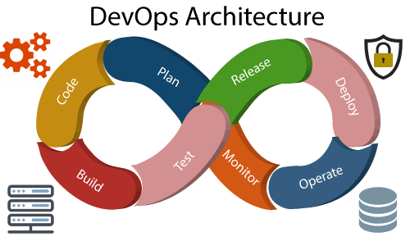

- Build - Without DevOps, the cost of the consumption of the resources was evaluated based on the pre-defined individual usage with fixed hardware allocation. And with DevOps, the usage of cloud, sharing of resources comes into the picture, and the build is dependent upon the user's need, which is a mechanism to control the usage of resources or capacity.
- Code - Many good practices such as Git enables the code to be used, which ensures writing the code for business, helps to track changes, getting notified about the reason behind the difference in the actual and the expected output, and if necessary reverting to the original code developed. The code can be appropriately arranged in files, folders, etc. And they can be reused.
- Test - The application will be ready for production after testing. In the case of manual testing, it consumes more time in testing and moving the code to the output. The testing can be automated, which decreases the time for testing so that the time to deploy the code to production can be reduced as automating the running of the scripts will remove many manual steps.
- Plan - DevOps use Agile methodology to plan the development. With the operations and development team in sync, it helps in organising the work to plan accordingly to increase productivity.
- Monitor - Continuous monitoring is used to identify any risk of failure. Also, it helps in tracking the system accurately so that the health of the application can be checked. The monitoring becomes more comfortable with services where the log data may get monitored through many third-party tools such as Splunk.
- Deploy - Many systems can support the scheduler for automated deployment. The cloud management platform enables users to capture accurate insights and view the optimization scenario, analytics on trends by the deployment of dashboards.
- Operate - DevOps changes the traditional approach of developing and testing separately. The teams operate in a collaborative way where both the teams actively participate throughout the service lifecycle. The operation team interacts with developers, and they come up with a monitoring plan which serves the IT and business requirements.
- Release - Deployment to an environment can be done by automation. But when the deployment is made to the production environment, it is done by manual triggering. Many processes involved in release management

commonly used to do the deployment in the production environment manually to lessen the impact on the customers.

Principles
  - Collaboration
  - Data-Based Decision Making
  - Customer-Centric Decision Making
  - Constant Improvement
  - Responsibility Throughout the Lifecycle
  - Automation
  - Failure as a Learning Opportunity

Advantages

  - DevOps is an excellent approach for quick development and deployment of applications.
  - It responds faster to the market changes to improve business growth.
  - DevOps escalate business profit by decreasing software delivery time and transportation costs.
  - DevOps clears the descriptive process, which gives clarity on product development and delivery.
  - It improves customer experience and satisfaction.
  - DevOps simplifies collaboration and places all tools in the cloud for customers to access.
  - DevOps means collective responsibility, which leads to better team engagement and productivity.

Disadvantages

- DevOps professional or expert's developers are less available.
- Developing with DevOps is so expensive.
- Adopting new DevOps technology into the industries is hard to manage in a short time.
- Lack of DevOps knowledge can be a problem in the continuous integration of automation projects.

Conclusion: Hence, we have known what DevOps is and its advantages and disadvantage

